
NITTE MEENAKSHI INSTITUTE OF TECHNOLOGY

(A Unit of Nitte Education Trust(R), Mangalore)

(AN AUTONOMOUS INSTITUTION AFFILIATED TO VISVESVARAYA TECHNOLOGICAL UNIVERSITY, BELGAUM)

ACCREDITED BY NATIONAL BOARD OF ACCREDITATION (AICITE), NEW DELHI

Govindapura, Gollahalli, P.B. No. 6429, Yelahanka, Bangalore 560-064, Karnataka, India

A seminar Report

On

DIFFERENT HELICOPTERS U S ARMY

Submitted in partial fulfilment for the Subject

Helicopter theory

Submitted by

Yashwanth Aradhya H R
(1NT15ME201)

VII Semester 'C' Section Department
of Mechanical Engineering
NMIT, Bengaluru.

Faculty Co-ordinator

MR. SUTHAN

Assistant Professor

Department of Aeronautical Engineering

NMIT, Bengaluru.

2018-19

CONTENTS

- INTRODUCTION TO HELICOPTER 1

- SELECTION CRITERIA 2

- AH 64E 3

- AH-1Z 5

- EUROCOPTER EC665 7

- MI28 8

- UH-60 13

- EC725 14

- MI-172A2 15

- CH47F 18

- CH53K 19

- MI26T2 21

1

Helicopters

This chapter analyzes a selection of attack, medium-lift, and heavy-lift helicopters in order to support the Army with its equipment-modernization investment decisions. We primarily looked at open source materials to examine a variety of military helicopters used by a number of foreign militaries. The platforms in Table 4.1 were included in the analysis.

Table 4.1. Helicopters Types and Platforms Included

Attack Helicopters Medium-Lift Helicopter Heavy-Lift Helicopters

AH-64E Apache Guardian AH-1Z Viper

Eurocopter EC665 Tiger Mi-28N Havoc Z-10
UH-60M Blackhawk Eurocopter EC725 Caracal Mi-171A2
CH-47F Chinook CH-53K Super Stallion Mi-26T2

Although this chapter does not include an analysis of specific scout/reconnaissance helicopters, the team did conduct a literature survey for this class of helicopter to see what was happening with existing inventories and whether new scout helicopter platforms were being developed around the world. The literature search of this class of aircraft allows some conclusions to be drawn about how the U.S. Army’s reconnaissance helicopter programs compare with foreign counterparts. Those insights will be provided at the end of this chapter.
As was the case with fires systems, it should be noted that different militaries have varying doctrines and philosophies regarding the use of helicopters. The U.S. Army has had a strong aviation branch since the Vietnam War in the 1960s, when thousands of helicopters were used. Today the U.S. Army has helicopter units in aviation brigades that are habitually associated with specific divisions (and prior to today’s organizational construct, Army helicopters were organic to divisions). In most other armies, helicopters are less numerous, and they can even be controlled and operated by the country’s air force. Even within the U.S. military there are different tactical employment concepts for attack helicopters. For example, the Marine Corps views its Cobra attack helicopters as a close air support (CAS) asset controlled and allocated in a manner similar to fixed-wing CAS aircraft. The Army, on the other hand, doctrinally views attack helicopter units as a maneuver unit.

Selection Criteria
Various foreign helicopter platforms were considered,³⁵ but specific platforms were chosen based on the priority of the system to the user nation (for example, the Mi-28 was chosen over the Ka-50 and Mi-24 because the Russian military has decided that the Mi-28 is its attack helicopter of the future). We also focused on state-of-the-art systems (as well as older systems undergoing extensive modernization upgrades) and similar mission aircraft (with search and rescue and antisubmarine helicopters excluded from the analysis since they have no U.S. Army counterparts); geographic representation; and the desire to include aircraft of friends and potential adversaries. Additionally, the analysis included several helicopters used by the Marine Corps.

Attack Helicopters

AH-64E General Platform Information
The AH-64E (Figure 4.1) is a four-blade, twin-engine, tandem, all-glass-cockpit attack helicopter manufactured by Boeing. It is known as the “Apache Guardian” (formerly the Apache Block III); it is the latest version of the Apache helicopter used by the U.S. Army, and it is a truly state-of-the-art platform. The first AH-64E was delivered to the Army in November 2011 and full-rate production was achieved in October 2012. As of January 2013, the Army had received 28 aircraft—enough to field its first full unit—but it plans on procuring a total of 690 through AH-64D model remanufacturing.

Figure 4.1. AH-64E Apache
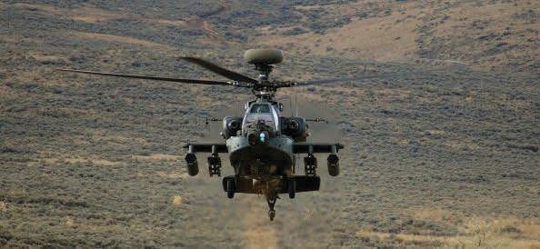

The AH-64E is armed with a variety of weapons, including a 30-mm chin-mounted cannon, 2.75" unguided rockets, advanced precision kill weapons systems (APKWS) laser- guided rockets, and Hellfire laser-guided missiles. The AH-64E also incorporates several new technologies designed to enhance the aircraft’s maneuverability, survivability, and lethality, such as an improved drive system, composite rotor blades, new engines enhanced by digital control units, the ability to control unmanned aerial system (UAS) navigation and payloads through the high-bandwidth UAS Tactical Common Data Link (CDL) Assembly, digital interoperability with many fixed-wing aircraft through a Link 16 data link, the Cognitive Decision Aiding System (CDAS) to reduce pilot workload, the dual-mode seeker Joint Air-to- Ground Missile (JAGM) for improved weapon-to-target match and extended range, the Joint Tactical Radio System for improved connectivity across waveforms, and fully integrated aircraft survivability equipment (ASE).³⁶
Marine Corps AH-1Z
The AH-1Z (Figure 4.2) is also a four-blade, twin-engine, tandem, all-glass-cockpit attack helicopter manufactured by Bell. Known as the “Viper” (or the “Zulu Cobra”), the AH-1Z is the latest version of the AH-1 helicopter used by the U.S. Marine Corps, and like the Apache, it is a state-of-the-art platform. The first AH-1Z was delivered to the Marine Corps in January 2007 and full-rate production was achieved in December 2010. As of April 2013, the Marine Corps had received 30 Vipers, but it plans on procuring a total of 226 through new builds and AH-1W model remanufacturing.

- See 2014 Army Equipment Modernization Plan, Headquarters, Department of the Army, May 13, 2013; Amy Butler, “U.S. Army Prepares for Full-Rate AH-64E Production,” AviationWeek.com, October 26, 2012; John Keller, “Boeing Moves Apache Block III Attack Helicopter Program Forward with $187 Million Army
Figure 4.2. AH-1Z Viper
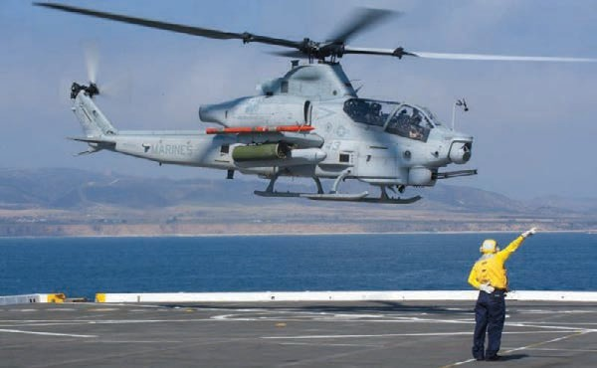

SOURCE: U.S. Navy photo by Mass Communication Specialist 3rd Class Dominique Pineiro.

The AH-1Z is armed with a 20-mm chin-mounted cannon, 2.75" unguided rockets, APKWS laser-guided rockets, Hellfire laser-guided missiles, and AIM-9 Sidewinder air-to-air missiles. Like the AH-64E, the AH-1Z incorporates several new technologies designed to enhance the Viper’s maneuverability, survivability, and lethality. However, unlike the AH- 64E, the Viper is part of a larger United States Marine Corps (USMC) modernization initiative called the H-1 Upgrade Program, which in addition to 226 Vipers, will deliver 160 state-of- the-art UH-1Y “Venom” utility helicopters—both of which are employed in USMC Light Attack Helicopter (HMLA) squadrons—that have 84 percent parts commonality with the Viper.
These upgraded technologies include composite rotor blades that more than double the payload capacity of the AH-1W, a composite rotor hub that has 75 percent fewer moving parts than four-blade articulated rotor hubs, the Topowl Helmet Mounted Sight and Display (HMS/D) system with fourth-generation day, night, and night vision goggle visor-projection technology; an advanced targeting system with third-generation FLIR that can identify targets in excess of the aircraft’s organic maximum weapons ranges; an integrated avionics system with an open architecture approach for 50 percent growth capacity; and a number of digital interoperability improvements, such as high-bandwidth CDL to send and receive full-motion video (FMV) and associated metadata, a digitally aided close air support (DaCAS) system for the digital exchange of CAS mission information, the next generation of Blue Force Tracker, and the Joint Allied Threat Awareness System (JATAS), which makes onboard ASE systems interoperable with the joint
European EC665
The Eurocopter EC665 Tiger (Figure 4.3) is four-blade, twin-engine, tandem, all-glass-cockpit attack helicopter manufactured by Eurocopter. The Tiger first became operational in the French and German militaries in 2005. As of December 2012, each country operated nearly 80 Tigers and each plans on procuring a total of 120 aircraft. In 2007, the Tiger became operational in the Australian and Spanish militaries, and each country currently operates approximately 20 Tiger variants. France, Germany, Australia, and Spain each use the Tiger in a slightly different manner based on emphasis given to air-to-air, air-to-ground, general support, or armed reconnaissance missions, and each military has procured slightly different subsystems tailored for their needs.

Figure 4.3. Eurocopter Tiger
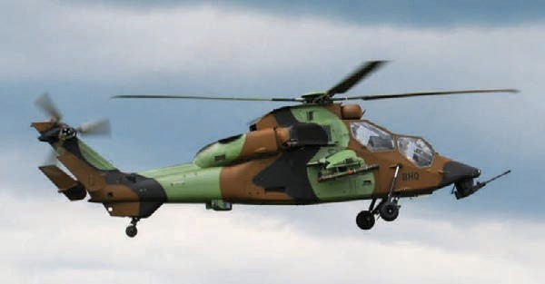

SOURCE: Photo by besopha, CC BY-SA 2.0.

However, 77 percent of all Tiger variants’ structural weight are components of carbon, aramid, or fiberglass, which allows an overall weight reduction up to 30 percent, corrosion- free structures, damage-tolerant behavior, and easy battlefield repair.
All Tiger variants are armed with a 30-mm chin-mounted cannon, but different variants use a mix of 70- and 68-mm unguided rockets; HOT, Trigat, Spike, Pars 3, and Hellfire antitank missiles; and Mistral and Stinger air-to-air missiles. Other modern technologies include the Thales Topowl HMS/D system (French versions); the BAE Systems day and night HMS/D (German version); the Australian Defence Industries (ADI) HMS/D system (Australia version); enhanced electromagnetic pulse (EMP) protection due to copper and bronze bonding throughout the fuselage; a mast or roof sight with an infrared charge coupled device (IRCCD) camera and
warfare suite that includes a radar warning receiver; a missile launch detector; and a chaff/flare dispenser.³⁸
Russian Mi-28N
The Mi-28N “Havoc” (Figure 4.4) is a five-blade, twin-engine, tandem all-glass-cockpit attack helicopter manufactured by Mil Helicopters. It is a dedicated attack helicopter, and unlike many armed Russian helicopters, it has no intended secondary transport capability. The first production aircraft was delivered to the Russian military in 2008, and the following year, the Mi-28N was delivered to its first operational unit. As of October 2012, there were 64 Mi-28N helicopters in service, and that number is expected to climb to 200 by 2015, which is the point at which it will completely replace the aging Mi-24 Hind.

Figure 4.4. Mi-28N Havoc
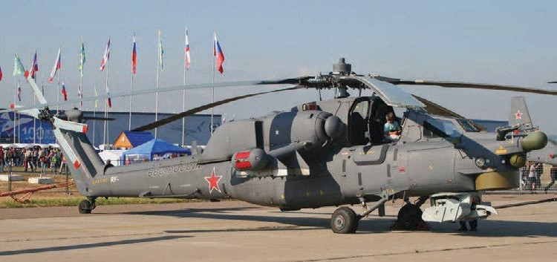

SOURCE: “Mil Mi-28N Havoc” shared via Flickr by Alan Wilson, CC BY-SA 2.0 Generic.

The Mi-28N is the world’s heaviest attack helicopter due, in part, to its heavily armed cockpits and a windshield that is able to withstand hits from 12.7-mm to 14.5-mm caliber rounds. The Mi-28N is armed with a 30-mm chin-mounted cannon that features side-mounted ammunition boxes to prevent jamming. The 30-mm gun is also the same gun installed on the BMP-3 IFV, BMD-2 AFV, BMD-3 AFV, and BTR-90 APC. The Mi-28N can also carry 80-
mm and 122-mm unguided rockets, AT-9 SACLOS and AT-12 laser-guided antitank missiles (with high-explosive antitank [HEAT] and thermobaric warheads), and SA-16 or AA-11 air- to-air missiles.

Other modernization technologies include composite rotor blades that can withstand hits up to 30 mm, an HMS/D system that can hand off targets to the navigator’s surveillance and fire control system, an integrated electronic combat system that includes a microwave radar antenna mounted above the rotor head (similar to the AH-64D, however this system is not currently being delivered to operational units), a FLIR, integrated laser designator and tracker, low-light level television, and digitized flight, systems, and target information on liquid crystal displays (LCDs). The Mi-28N is also built with enhanced survivability features, such as engines with suppressed exhaust that enable a 2.5-times reduction in thermal signature from the Mi-24 predecessor and an emergency jettisoning system that blows off stub wings and canopy doors to allow for pilot bailout (pilots wear parachutes). The Mi-28N also has an ASE suite that includes a laser warning receiver, flare dispensing system, radar jammer, and radar and missile warning receivers; however, the aircraft is currently being delivered to flying units without the installed ASE equipment.³⁹
Chinese Z-10
The Chinese Z-10 (Figure 4.5) is a five-blade, twin-engine, tandem, all-glass-cockpit attack helicopter manufactured by Changhe Aircraft Industries Corporation (CAIC). The Z-10 is the first indigenous Chinese attack helicopter; however, the Chinese had considerable assistance from the Russians to develop the aircraft. The Chinese also had assistance from by Pratt & Whitney Canada, which provided the aircraft’s engines before the company was fined US$75 million by the U.S. government for a violation of export rules. As of January 2013, the Chinese had fielded 48 Z-10 helicopters, which are organized into four different squadrons, each of which has 12 helicopters.
The Z-10 is armed with a 23-mm cannon, 57- or 90-mm unguided rockets, HJ-9 antitank guided missiles (comparable to the TOW-2A), HJ-10 antitank missiles (comparable to the AGM-114 Hellfire), and TY-90 air-to-air missiles. Z-10 helicopters, however, are seldom observed with weapons, and as of late 2012, they have never been seen in flight with a full weapons load. The Z-10 has a millimeter-wave fire-control radar (like the Apache Longbow), the Infrared Search and Track (IRST) system, a low-light level television camera, and a laser designator. Both pilots have HMS/D with integrated night vision optics, although export variants are not offered with this capability. The Z-10 is outfitted with a fully integrated ASE
system and an electronic warfare (EW) system that can degrade incoming tracking signals through a jamming pod. Although the Z-10 is assessed to be a formidable force within the next decade—
Figure 4.5. Z-10
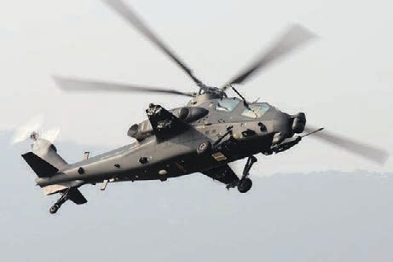

SOURCE: Photo by Shimin Gu, GNU Free Documentation License, Version 1.2.

General Characteristics of Attack Helicopters
Table 4.2 presents the general characteristics of attack helicopters.

Table 4.2. General Characteristics of Attack Helicopters
Helicopter Operational Introduction |  | Number in Export Location Max Weight/ Max Speed Max Range Service Max Payload (max/cruise)
AH-64E |  |  | Taiwan and South Korea;
Apache Guardian | 2012 | 690 (planned) | possibly Qatar, 23,000 lbs 158/143 knots 260 NM UAE, and Saudi  Arabia
AH-1Z Viper | 2010 | 226 (planned) | South Korea 18,500 lbs 155/134 knots 370 NM

5,764 lbs
430 NM
150 124 knots
14,553 lbs
3,968 lbs
Australia, UK, Netherlands, and Spain
France: 120 (planned) Germany: 120 (planned)
2003
Eurocopter EC665 Tiger

Mi-28N Havoc 2009 200 (planned) Iraq and Kenya 25,350 lbs
5,180 lbs
172/145 knots 234 NM

Z-10
2009
48 (currently)Unknown
15,432 lbs161/135 knots
430 NM

- “Z-10 Attack Helicopter, China,” Army-Technology.com, undated.

Attack Helicopter Platform Trends and Insights
The section presents trends and insights regarding attack helicopter platforms. There is increased sophistication in U.S. and foreign platforms: All modern attack helicopters are being built with:
  - Composite materials
  - Fly-by-wire (FWB) electronic controls
  - All-glass cockpits with large-screen, liquid-crystal, multifunctional displays
  - Helmet-mounted targeting displays
  - Hellfire class missile systems
  - Integrated and advanced ASE suites
  - Enhanced survivability.
Regarding U.S. dominance in targeting system capability: U.S. attack helicopters have a significant lead in this area due to:
  - Ability to receive and retransmit FMV UAS feeds
  - Sensor-to-weapon match: third-generation FLIRs with greater target identification ranges.
Regarding U.S. dominance in weapons system capability: U.S. attack helicopters have significant lead in the area due to:
  - Lower-yield, lower-cost PGM options (APKWS II)
  - Development of dual-mode seeker for PGM (JAGM). Foreign platform shortfalls can be compared with U.S. attack helicopters:
  - Russian Mi-28s are currently being delivered without radar and ASE systems
  - Chinese Z-10s currently have engine problems and there is little evidence of use of Z-10 weapons systems
  - Eurocopter Tiger can only carry eight Hellfire missiles and does not have state- of-the-art FLIR.
Foreign attack helicopter platforms do have niche specialties:
  - Chin-mounted cannons have attached ammo boxes that slew and elevate with a gun, a feature that tends to reduce jamming
  - Chin-mounted cannons can be found on IFVs (for example, the 30-mm cannon on Mi-28 and BMP-3), which reduces maintenance training
  - Non-U.S. attack helicopters tend to be:
- Less expensive
- Have variants compatible with Western avionics/weapons systems
- Production contracts have in-country manufacturing agreements in order to remain competitive with U.S. FMS platforms
  - Eurocopter has enhanced EMP protection.
The U.S. Army Apache and USMC Cobra can be compared:
  - AH-64E:
- Hellfire missile range out to eight km (using radar mode)
- Dual-mode JAGM⁴¹
- Radar capability
- Level IV control over UAS (for payload and navigation)
- Link-16 interoperability⁴²
  - AH-1Z:
- 84 percent commonality with UH-1Y to reduce maintenance train
- Software Reprogrammable Payload (SRP) and Variable Message Format (VMF) technologies (future digital interoperability improvements)⁴³
- Better targeting system:
- Greater FLIR and Charge-Coupled Device Television (CCD-TV) identification ranges
- Continuously variable zoom (versus static family of vehicles)
- Lower spot jitter
- Smaller laser beam divergence (more PGM accuracy at longer ranges)
  - Both have tactical video data links and interoperability with UASs, ground combat systems (GCSs), and joint strike assets
  - Both have state-of-the-art, fully integrated ASE suites.

- In February 2012, the Navy and the Marine Corps terminated its investment in the JAGM.
- Link 16 is tactical data link used to exchange near real-time communication, navigation, and identification information and supports information exchange between disparate C4I systems. The radio transmission and reception component of Link 16 is based on the high-capacity, ultra-high-frequency (UHF), line-of-sight waveform and can frequency hop, which provides secure, jam-resistant voice and digital data exchange. Link 16 operates on the principle of Time Division Multiple Access, wherein time slots are allocated among all network participants for the transmission and reception of data. Many joint Air-Ground platforms have Link 16 capability to include F-16s, F-15s, F/A-18s, E-2C2s, P-3Cs, EA-6Bs, EP-3Cs, RC-135s, KC-130Js, E-8J STARS, MH-
60S/Rs, Carrier Battle Groups, Amphibious Ready Groups, Patriot Information Coordination Centers, USMC Tactical Air Command Centers, Air Force Air Operations Centers, and various UAS Ground Control Systems. Link 16 information is coded in binary J-series message protocol (MIL-STD 6016) and is passed in one of three data rates—31.6, 57.6, or 115.2 kilobits per second—all of which are relatively low bandwidth.
- VMF is bit-oriented digital information that facilitates the exchange of K-Series messages described in MIL- STD-6017 (Military Standard–6017). It is waveform independent, so it can be exchanged using wireless systems (such as HF, VHF, UHF, and SATCOM) and wired systems (such as Ethernet or fiber optic systems). K-Series message protocol enables it to have more-efficient use of bandwidth capacity due to the fact that multiple messages may use a single message heading. J-Series messages, however, require headers for each message, which decreases bandwidth capacity efficiency.

Medium-Lift Helicopters

UH-60M General Platform Information
The UH-60M Black Hawk (Figure 4.6) is a four-blade, twin-engine, medium-lift, utility helicopter manufactured by Sikorsky. It serves as the U.S. Army’s utility helicopter for squad- size assault operations, but it also performs general support, command and control, and aeromedical evacuation missions. It was designed to replace the UH-60A and provides additional payload, range, and advanced digital avionics; better handling qualities; better pilot situational awareness; active vibration control; and improved survivability. Full-rate production began in 2007, and as of May 2013, the Army had approximately 400 in use. By FY 2027, the Army plans on procuring a total of 1,375 UH-60M Black Hawks through new builds.

Figure 4.6. UH-60M Black Hawk
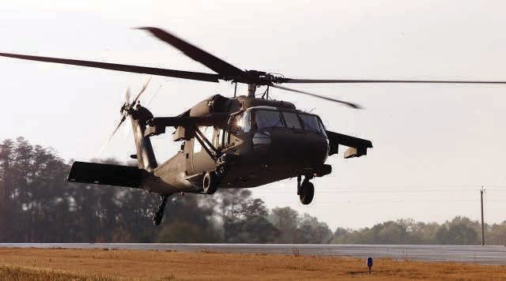

SOURCE: Photo by the U.S. Army.

The UH-60M modernization program progresses within a block approach wherein Block I incorporates a digital cockpit, digital flight controls, wide-chord rotor blades, a more powerful General Electric T-700-GE-701D engine, and an integrated vehicle health management system (IVHMS). Block II incorporates improved ASE in the form of an enhanced AVR2B laser warning system; improved infrared suppression and the Common Missile Warning Systems (CMWS); improved survivability due to 23-mm antiaircraft artillery (AAA) tolerant rotor
Importantly, CAAS is compatible with K-Series VMF messaging and is installed on many other helicopter platforms, including a number of special operations forces helicopters (AH-6, MH-6, MH47D, MH-47E, and MH-60K), Army CH-47Fs, the Marine Corps CH-53E/Ks, and Coast Guard HH-60s.⁴⁴
European EC725
The Eurocopter EC725 Caracal (Figure 4.7) is a five-blade, twin engine, glass-cockpit, medium-lift, multirole helicopter manufactured by Eurocopter. It is an evolved version of the SuperPuma/Cougar family of helicopters and is used by the French Air Force and Army for special operations, search and rescue, tactical transport, and aeromedical evacuation missions from the sea or on land. It was declared operational in May 2007, and by February 2013, 21 EC725s had been delivered to the French military. It has a 463 NM range using internal fuel tanks but can nearly double its range by carrying up to 630 gallons of auxiliary fuel.

Figure 4.7. Eurocopter EC725 Caracal
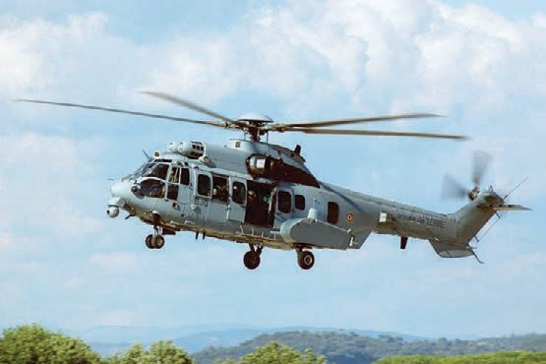

SOURCE: Photo by Jeff Web, CC BY-SA 3.0.

The Caracal improves on the SuperPuma/Cougar helicopter platforms by incorporating composite materials into the main rotor blades, a new rotor blade shape to reduce vibration levels, a fiberglass main rotor hub, armor plating to protect the cockpit and the main cabin,

- See 2014 Army Equipment Modernization Plan, 2013; “UH-60M,” Globalsecurity.com, last modified July 7, 2011; “Common Avionics Architecture System (CAAS),” Rockwellcollins.com, undated; Paul Clements and John Bergey, The U.S. Army’s Common Avionics Architecture System (CAAS) Product Line: A Case Study, Carnegie Mellon Software Engineering Institute Technical Report, September 2005; David Jensen, “What’s New
more-powerful Turbomeca Makila 2A1 turboshaft engines with full authority digital engine control (FADEC), a reinforced main rotor gearbox, an inflight refueling probe for extended mission range, an all-glass cockpit with liquid crystal multifunction displays, and an advanced helicopter cockpit and avionics system (AHCAS), and it can be fitted with a navigation FLIR and radar.
Medevac variants can carry up to 12 litters and combat assault support variants are armed with door-mounted 7.62-mm machine guns and side-mounted 68-mm rocket pods or side- mounted 20-mm cannon pods. All variants can be outfitted with a chaff/flare dispenser, radar warning receiver, and missile approach warning. The Caracal is also marketed for civilian firefighting purposes.⁴⁵
Russian Mi-171A2
The Mi-171A2 (Figure 4.8) is a five-blade, twin engine, glass-cockpit, medium-lift, multirole helicopter manufactured by Mil Helicopters. Only two test aircraft currently exist, but the first deliveries are expected by the end of 2014. Currently marketed primarily as a civilian helicopter for export, the Mi-171A2 is designed to replace the Mi-8/17 “Hip” (which has been exported to nearly 60 countries) and features more than 80 technological improvements over its predecessor. These improvements include new, more powerful Klimov CK-2500PS-03 turboshaft engines with FADEC capability, a new rotor system with composite blades, a new airframe constructed with 20–30 percent composite materials, and the latest suite of integrated KBO-17 avionics developed by Radioelectronics Technologies, featuring an all-glass instrument panel and an onboard digital diagnostic maintenance system that monitors major component operating time while retaining information in the memory. The Mi-171A2 also features all-weather digital television and thermal imaging cameras for 360-degree situational awareness and collision avoidance, and a PKV-171 digital flight control system.

Figure 4.8. Mi-171A2
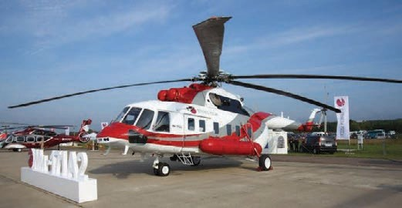

The Mi-171A2 has a 459-NM maximum range using internal fuel but can more than double its range by carrying up to 753 gallons of auxiliary fuel. It can accommodate 12 litters for the aeromedical evacuation mission and is touted for its potential civilian applications, such as forest protection, construction, loading and unloading operations, firefighting, and search and rescue. Although military applications for the Mi-171A2 are still in development, it is assessed that the new helicopter can carry up to 3,300 pounds of armament on wing stores that include antitank missiles, air-to-air missiles, rockets, and gun pods. ASE integration for this particular Mi-8/17 variant is also lacking, but older versions have been outfitted with the infrared jammers and suppressors, flare dispensers, and EW capabilities that are assessed to be readily transferable to the military variant of the Mi-171A2.⁴⁶
General Characteristics of Medium-Lift Helicopters
Table 4.3 presents the general characteristics of medium-lift helicopters.

Table 4.3. General Characteristics of Medium-Lift Helicopters
 | Operational | Number in | Export |  | Max Speed | Max Range/
Helicopter | Introduction | Service | Locations | Useful Payload | (max/cruise) | Aerial Refuel
11 combat loaded
soldiers 276 NM
UH-60M 2007 1,192 (planned) 7 countries Int. capacity: 160/151 Cannot aerial Black Hawk 2,600 lbs. knots refuel
Underslung Internal 360-
payload: 9,000 lbs gallon capacity
Eurocopter EC725 | 2006 | 21 (current) | 6 countries | 25 seated combat troops Int. capacity: 5,500 lbs | 175/142  knots | 463 NM  Can aerial refuel
Caracal |  |  |  | Underslung | Internal 683-
 |  |  |  | payload: | gallon capacity
 |  |  |  | 10,472 lbs
 | 2 test aircraft |  | None; however, | 26 combat
 | exist |  | nearly 2,500 | troops | 459 NM
Mi-171A2 2014 Testing began base models Int. capacity: 151/140 Cannot aerial Hip (expected) in 2012, but fewer have been 8,818 lbs knots refuel
than 12,000 base exported to Underslung Internal 898-
models have nearly 60 payload: gallon capacity been produced countries 11,023 lbs
NOTE: Max range is without auxiliary fuel tanks.

Medium-Lift Helicopter Platform Trends and Insights
The section presents trends and insights regarding medium-lift helicopter platforms. There is increased sophistication in U.S. and rest of the world (ROW) platforms. All medium-lift helicopters are being upgraded or built with:
  - Composite materials
  - Enhanced survivability
  - More-fuel-efficient engines with FADEC capability
  - FWB electronic controls
  - All-glass cockpits with large-screen, liquid-crystal, multifunctional displays
  - Multipurpose flexibility—e.g., FLIR and weapons options.
U.S. Army UH-60M Black Hawks have a smaller useful payload, but it is purposefully built for U.S. Army squad operations. Black Hawks also have an advantage in:
  - Digital network connectivity and interoperability with joint air-ground platforms
  - Aircraft survivability.
Foreign platforms have some niche specialties (and different design philosophies):
  - Mi-171A2 has robust armament capabilities
  - EC725 can conduct aerial refueling
  - EC725 can perform dedicated combat search and rescue (CSAR) mission using dedicated radar capabilities
  - All variants of EC725 and Mi-171A2 have navigation FLIRs
  - Foreign systems have higher useful payloads and medevac capacities
  - Foreign systems have longer maximum range using internal and auxiliary fuel tanks.

Heavy-Lift Helicopter Platforms

CH-47F General Platform Information
The CH-47F Chinook (Figure 4.9) is a multiengine, tandem-rotor, glass-cockpit, heavy-lift helicopter manufactured by Boeing. It is employed in the U.S. Army’s general support aviation hattalions (GSABs) and conducts troop movement, artillery emplacement, and battlefield resupply missions. As of November 2012, the Army had received 211 F-model Chinooks, but the Army Modernization Program calls for a total of 464 CH-47Fs, through a combination of 253 complete new builds and 211 like-new aircraft using selected recapitalized CH-47D components, by 2017. These deliveries occur within two multiyear contracts, known as MYI and
Figure 4.9. CH-47F Chinook
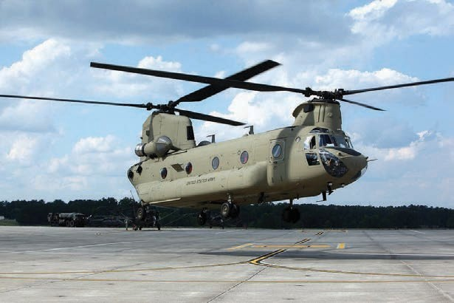

SOURCE: Photo by Sgt. 1st Class Roy Henry, Public Affairs Office, Georgia Department of Defense, CC BY 2.0.

The CH-47F incorporates several new technologies, including a new “machined” airframe that decreases weight and increases strength, the more powerful and fuel-efficient Honeywell T55- GA-714A turboshaft engines with FADEC capability, the same Rockwell Collins CAAS cockpit installed in the UH-60M that has digital data bus architecture, high-definition liquid crystal multifunction displays, redundant high-integrity Ethernet data buses, electronic K- Series VMF messaging, built-in systems diagnostics, and modularity for future upgrades. The F-model Chinook also features the Digital Advanced Flight Control System (DAFCS), which provides a level of flight automation to typical maneuvers performed by Chinook pilots, such as hovering and landing from a hover.
Future planned upgrades also include the composite Advanced Chinook Rotor Blade (ACRB) that will debut in 2016 and increase aircraft lift capacity by 2,000 pounds; the Active Parallel Actuator System (APAS) to enhance the DAFCS by providing improved rotor torque management; a new streamlined and more efficient fuel system (derived from the special operations MH-47G variant) that decreases fuel system weight and adds fuel capacity, thereby increasing range and lift capacity; and a completely upgraded electrical system.⁴⁷

- See 2014 Army Equipment Modernization Plan, 2013; Sofia Bledsoe, “Team Chinook Signs CH-47F MYII Contract; Cost Savings of $810 Million,” Army.mil, June 14, 2013; Graham Warwick, “Block 2 CH-47F to Tackle Payload Shortfalls,” Military.com, April 22, 2013; “Boeing Awarded U.S. Army Contract for 14
USMC CH-53K
The CH-53K King Stallion (Figure 4.10) is a seven-blade, three-engine, heavy-lift cargo helicopter manufactured by Sikorsky. It is currently in development, and the first preproduction test aircraft is scheduled for delivery in late 2013. It is scheduled to become operational in 2018 in the USMC, and USMC procurement plans call for a total of 227 CH- 53Ks. When it is fielded, the CH-53K will be the largest and heaviest helicopter in the U.S. military, at a maximum gross weight of 88,000 pounds.

Figure 4.10. CH-53K King Stallion
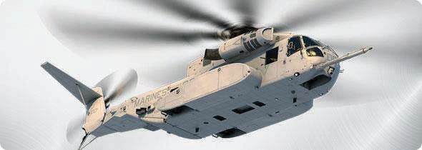

SOURCE: Publicity photo from Sikorsky.

The CH-53K improves on the CH-53E aircraft currently in use by the U.S. Marine Corps and features more-powerful General Electric GE38-1B engines, high-efficiency composite rotor blades with anhedral tips, and a composite airframe that significantly increases useful payload. The CH-53K also has a wider cabin to fit a High Mobility Multipurpose Wheeled Vehicle (HMMWV) internally, fly-by-wire electronic flight controls, a navigation FLIR with integrated HMS/D, and a significantly revamped cockpit that features the Rockwell Collins Avionics Management System (AMS), which, like the UH-60M and CH-47F, integrates communications, navigation, weapons, and mission subsystem information for improved pilot situational awareness and is compatible with K-Series VMF messaging.
Survivability improvements also include advanced lightweight armor protection for the aircrew and crash-worthy seats for troops in the cabin. The CH-53K will be able to carry 24 litters in the aeromedical evacuation role, will also be able to carry two 463L pallets internally, and has three cargo hooks that can carry an external load of 36,000 pounds.⁴⁸

- See U.S. Government Accountability Office, Defense Acquisitions: Assessments of Selected Weapon Programs, GAO-13-294SP, March 2013, pp. 53–54; “Marines Up Order for New Heavy Lifter,” Rotor & Wing, August 1, 2007; “CH-53X Super Stallion,” Globalsecurity.org, undated; “New Heavy Lift Helicopter Starts
Mi-26T2
The Mi-26T2 (Figure 4.11) is an eight-blade, twin-engine, heavy-lift helicopter manufactured by Mil Helicopters. It is currently in development and is planned to be used by the Russian Air Force after its scheduled operational debut in 2014. The Mi-26T2 is a modernized version of the Mi-26 Halo, which is the biggest helicopter in the world, and has several updated technologies, including glass-fiber reinforced plastic (GFRP) rotor blades, a titanium rotor head, and Ivchenko-Progress ZMKB D-136-2 engines with FADEC capability that can produce 11,490 shaft horsepower.

Figure 4.11. Mi-26T2
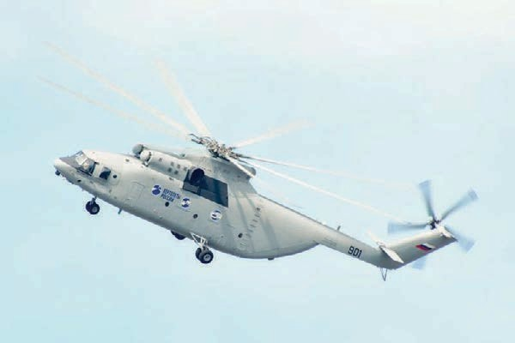

SOURCE: “Mil Mi-26T2” shared via Flickr by José Luis Celada Euba, CC BY 2.0.

The Mi-26T2 also features a modern avionics suite designed by Ramenskoye Design Company, including five large-screen multifunctional LCDs, a digital navigation system, FWB electronic controls, an integrated navigation FLIR and laser rangefinder, and a closed- circuit television camera to observe slung payloads.
The cargo load of the Mi-26T2 is wider and taller than a C-130J and is capable of carrying two airborne infantry combat vehicles, 90 combat-loaded troops, 60 aeromedical evacuation litters, or six 463L pallets. The aircraft is also being marketed for civilian purposes, such as construction, logging operations, and firefighting duties.⁴⁹

Development,” U.S. Marine Corps, press release, January 9, 2006; “Sikorsky Aircraft Selects Rockwell Collins to Provide CH-53K Avionics Management System,” Sikorsky.com, June 29, 2006; “Sikorsky CH-53K Super
General Characteristics of Heavy-Lift Helicopters
Table 4.4 presents the general characteristics of heavy-lift helicopters.

Table 4.4. General Characteristics of Heavy-Lift Helicopters

Helicopter
Date of Introduction
Number in
Service Useful Payload
33 combat soldiers
Cargo Bay Dimensions

30.5-ft. long
Max Speed (max, cruise)
Max Range/ Aerial Refuel
400 NM
Cannot aerial

CH-47F
Chinook
2007 464 (planned)
Int. capacity: 28,000 lbs Ext. capacity: 25,000 lbs
37 combat troops
7.5-ft. wide 6.5-ft. tall

30-ft. long
170/130 knots
refuel
Int. fuel: 1,034 gallons

454 NM
Aerial

CH-53K
King Stallion
2015
(expected)
227 (planned)
Int. capacity: 35,000 lbs Ext. capacity: 36,000 lbs

90 combat
9-ft. wide 6.5-ft. tall

39ft 7.5” long
8’ wide
170/140 knots
refuelable
Int. fuel: 2,286 lbs

430 NM
Cannot aerial

Mi-26T2 Halo 2014
(expected)
42 (planned)
troops
Int. capacity: 44,092 lbs
10’ 4.75” tall
**wider and taller than C- 130J**
159/132 knots
refuel
Int. fuel: 3,170 gallons

NOTE: Max range is without auxiliary fuel tanks.

Heavy-Lift Helicopter Platform Trends and Insights
The section presents trends and insights regarding medium-lift helicopter platforms. There is increased sophistication in U.S. and ROW platforms. All heavy lift helicopters are being upgraded or built with:
- Composite materials
- Enhanced survivability
- More-fuel-efficient engines with FADEC capability
- FWB electronic controls
- All-glass cockpits with large-screen, liquid-crystal, multifunctional displays.
U.S. heavy lift helicopters have a significantly lower payload than Mi-26T2, yet greater maneuverability. They also have a greater digital network connectivity than Mi-26T2.
Regarding foreign niche specialties, Mi-26T2 has many variants (flying hospital, crane, tanker, and firefighter), which makes it more marketable for civilian purposes. And Mi-26T2 is truly in a different cargo class (C-130 class payload).

If we compare the CH-47F with the CH-53K, we find:
  - The CH-47F is much less expensive to operate ($12,000 per flight hour versus
$20,000)
  - The CH-47F is more maneuverable and can access more-confined landing zones due to tandem rotor and faster approach speeds
  - The CH-47F has structural modifications for faster loading and unloading on C- 5
  - The CH-53K has higher payload capability:
- The CH-53K has a third engine and can carry 7,000 pounds more.
- The CH-53K is 18 inches wider, which can accommodate HMMWVs and Mine Resistant Ambush Protected (MRAP) vehicles
  - The CH-53K has FLIR and integrated helmet-mounted navigation system
  - Both have cutting-edge tactical digital connectivity
  - Both have extensive avionics upgrades.
  - Both have similar strategic transportability (two on C-5)
  - Both can carry three 463L pallets.

Scout Helicopters
Recent research into global trends at the unclassified level in scout and reconnaissance helicopters indicates that very few new specialized observation helicopters are being developed or procured. In particular, The International Institute for Strategic Studies 2013 Military Balance journal shows limited proliferation and procurement of scout helicopters as well as a reduction in scout helicopter inventories. France and Australia, for example, are replacing their aging scout helicopters (Gazelles and OH-58 Kiowas, respectively) with attack helicopters (Eurocopter Tigers) that are to be used in the dual roles of attack and reconnaissance. They are also procuring more UAS assets designed to be interoperable with these attack helicopters. Thus, U.S. Army plans to procure a new observation helicopter are an outlier in terms of global trends.
It should be noted that the U.S. Army also uses its OH-58 aircraft in a light-armed attack role. In Iraq and Afghanistan, for example, OH-58s provided armed reconnaissance for convoys, trying to identify ambushes prior to a convoy reaching the danger point. Those same helicopters provided fires when troops were in contact with the enemy. So in that sense the Army is using the OH-58 aircraft in a light-attack role, which is beyond the helicopter’s original mission profile.
Implications from this observation are varied. On the one hand, it may be concluded that the need for a dedicated scout helicopter platform is decreasing

